Tasks:

1. Write an update statement in a transaction with a commit and rollback:

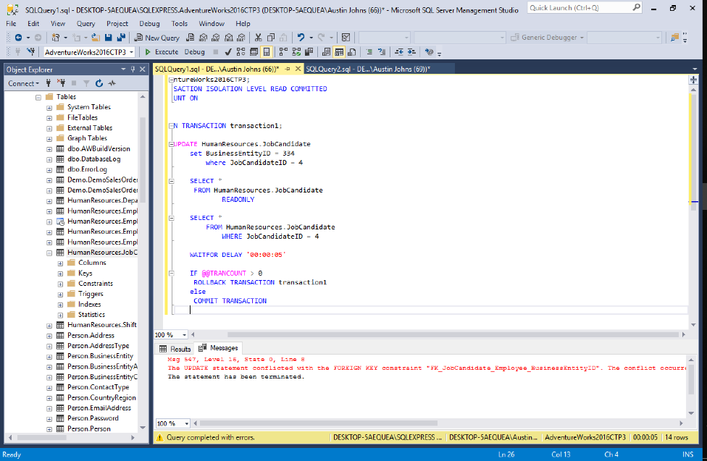

As seen above, the update was terminated because of the error failsafe. The primary key constrained the update form running, so the statement was terminated. The rollback worked successfully.

1. Write an insert statement in a transaction with a commit and rollback

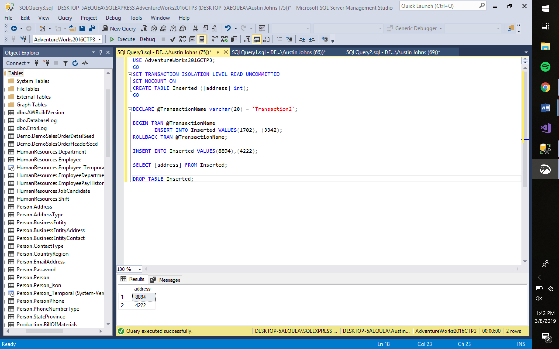

As seen above, in a transaction, the values for Address were inserted into the table.

1. Write a delete statement in a transaction with a commit and rollback.

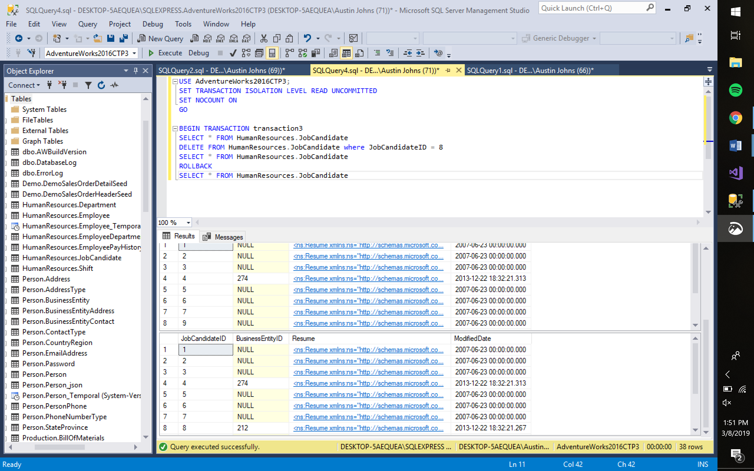

As seen above, the initial query is executed in which Job Candidate ID 8 is deleted. Next, the command is rolled back and appears back into the table.

1. Review a select with (read-only) and how that operates in the database.

A read only table operates like any other table, just there is no DELETE or INSERT function for the table. In a read-only table, it cannot be changed by the user. The read-only table helps protect data because it restricts who has access to altering it.

1. Review a select without (read-only) and how that operates in the database.

A table without read-only functionality is completely alterable by any user of the database. When a table isn’t read-only, the data is less secure because it’s editable by all users.

Link to the Database Backup: <https://drive.google.com/file/d/1-SgV0wQYV5G5-ofqyACuoeIWQLkl_PpX/view?usp=sharing>